WEEK 4:

Week 4.1:
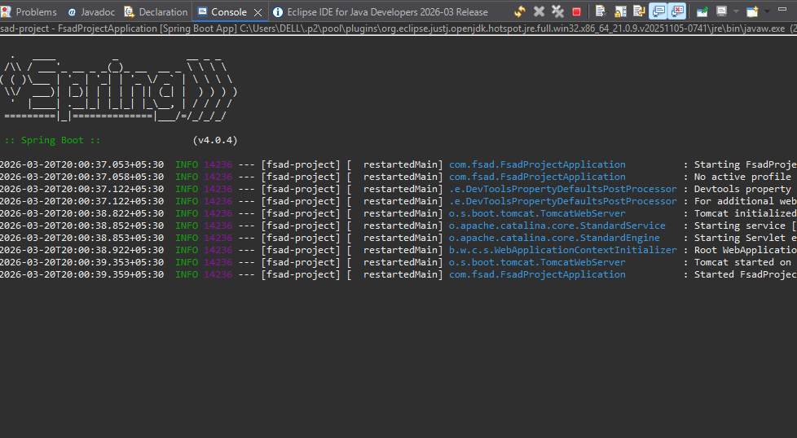

Changing port to 9090:
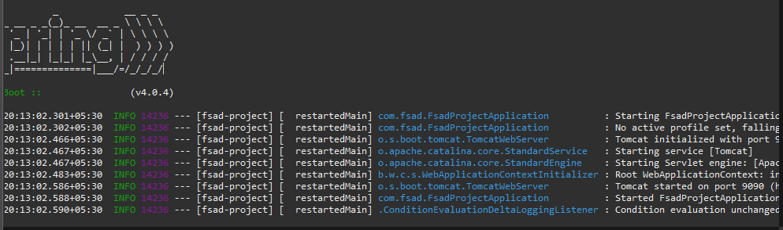

Task 4.2:
This one requires us to understand controllers, dependencies, services. At the end we will be using browser to test communication.
Let us see what @autowired does:
Consider the analogy of being a chef. So a waiter (Controller) brings request to you from the customer (the browser sends a request for something) and the controller comes to the kitchen (service) for the processing of the request.
Now let us consider this. We need a dependency to process the request. For example, to cook a meal(meal->request) that the customer has requested (customer->browser) requires a knife (knife->dependency). So there are 2 ways, 1. The chef creates the knife, which is unnecessary, second, he can GET the knife, which is ideal.
So when we say @autowired, we essentially tell Spring to take care of the dependency required for the service instead of making it by ourself.
So, we created A HelloService class which prints “Hello From Service!” onto browser upon being given a request to do so. Who takes care of handling requests? Controller. So we create controller next.
There are 2 things here:
POST: Here, we POST something FROM the browser into the back end. Imagine that the requester is the browser. He is requesting u to POST the content into the back end or the database (like form submission).
GET: Here, we GET something from back end or database or whatever to the browser. So the browser is requesting to “GET” content onto its screen.

So the HelloService Is essentially “GET”.
HelloService:
package com.fsad;
import org.springframework.stereotype.Service;
@Service
public class HelloService {
public String getMessage(){
return "Hello from service!";

}

}

HelloController:
package com.fsad;
import org.springframework.beans.factory.annotation.Autowired;
import org.springframework.web.bind.annotation.GetMapping;
import org.springframework.web.bind.annotation.RestController;
@RestController
public class HelloController {
@Autowired
HelloService helloService;
@GetMapping("/hello")
public String hello(){
return helloService.getMessage();
}}

@RestController tells spring that the class is the controller and handles web requests.
@Autowired tells spring that there already exists a class called HelloService so it need not create a new one and can take it from there.
@GetMapping Tells spring that when the link has /hello it should perform the service required.
And finally we create a method which returns the string in the getMessage() method of helloService created earlier. Thus the localhost displays the following:
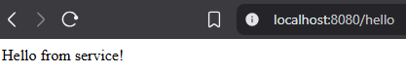

Task 4.3:
Here we do contructor injection in place of field injection.
Let us understand what that is. So a field injector directly “injects” the dependency into the class wherever @Autowired is written. But that is an issue. It is like, the controller is made to exist first and the service (dependency/knife) exists later. It means that the Controller can also exist without a service. Which kitchen doesn’t have a knife and borrows it later? That is faulty.
So we use Constructor injection. A constructor ensures that whenever controller is created, it is created with the dependency needed. Fool proof!

What allows us to create a class first and decide its implementation (The how to do this thing) later on?
INTERFACE.
So we will be using that.
So we make PaymentService interface:

package com.fsad;

public interface PaymentService {
String processPayment();

}

It just states that “Whoever creates this and implements it as a class, needs to implement the processPayment(); method -> So this is constructor injection.

To implement it we made: PaymentServiceImp1 class:
package com.fsad;
import java.lang.Override;
import org.springframework.stereotype.Service;
@Service
public class PaymentServiceImp1 implements PaymentService {
@Override
public String processPayment() {
return "Payment processed successfully!";
}

}

We state that it is a service so that the spring understands it. The override essentially overrides the declaration and explains WHAT has to be done in the processPayment() method. So here we just return “Payment processed successfully!”

Service is done, next we need controller. Hence, we make a class called PaymentController:
package com.fsad;
import org.springframework.web.bind.annotation.GetMapping;
import org.springframework.web.bind.annotation.RestController;
@RestController
public class PaymentController {
private final PaymentService paymentService;
public PaymentController(PaymentService paymentService){
this.paymentService = paymentService;
}
@GetMapping("/payment")
public String payment() {
return paymentService.processPayment();
}

}

So, since we are implementing PaymentService, it said that the method payment() needs to be implemented in it for sure.
Above in the line:
private final PaymentService paymentService;
We are saying that we are creating an instance of a datatype “PaymentService” which we made as an interface previously. We gave this implementation the name paymentService.
Next, we said that in PaymentController, we will use this interface, telling the controller that the interface that will be used inside is the interface created and declared earlier as paymentService.
At the end we implemented the payment() method. Finally inside the payment method, processPayment, who's implementation is given in PaymentServiceImp1, is called.

Upon pasting: http://localhost:8080/payment in browser:
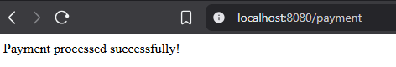

Task 4.4:
Goal: When multiple classes implement the same interface, how does spring know which one to call when @Autowired is given?
It uses: @Qualifier to specify furthermore, exactly what the @Autowired needs to call.
So for this task, we create:
- NotificationService — interface
- EmailNotificationService — implements it, marked @Service
- SMSNotificationService — implements it, marked @Service
- NotificationController — uses @Autowired + @Qualifier to pick one

NotificationService -> Interface:
package com.fsad;

public interface NotificationService {
String sendNotification();

}

EmailNotificationService -> Class:
package com.fsad;
import org.springframework.stereotype.Service;
import java.lang.Override;
@Service
public class EmailNotificationService implements NotificationService{
@Override
public String sendNotification() {
return "Email notification sent!";
}
}

SMSNotificationService -> Class:

package com.fsad;
import org.springframework.stereotype.Service;
@Service
public class SMSNotificationClass implements NotificationService{
public String sendNotification() {
return "SMS notification sent!";
}

}

NotificationController -> Class

package com.fsad;
import org.springframework.beans.factory.annotation.Autowired;
import org.springframework.beans.factory.annotation.Qualifier;
import org.springframework.web.bind.annotation.GetMapping;
import org.springframework.web.bind.annotation.RestController;
@RestController
public class NotificationController {
@Autowired
@Qualifier("emailNotificationService")
NotificationService notificationService;

@GetMapping("/notify")
public String sendNotify() {
return notificationService.sendNotification();
}
}

So when I add:
http://localhost:8080/notify
We get:
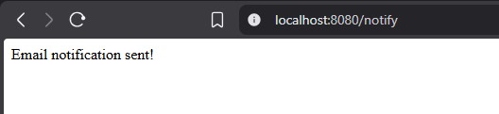

Task 4.5: Consider Autowired(required=false). It means that the browser could use the dependency or it could manage without it too. So that way even if the dependency doesn’t exist, it doesn’t crash.
So we edited the NotificationController by this content:

package com.fsad;
import org.springframework.beans.factory.annotation.Autowired;
import org.springframework.beans.factory.annotation.Qualifier;
import org.springframework.web.bind.annotation.GetMapping;
import org.springframework.web.bind.annotation.RestController;
@RestController
public class NotificationController {
@Autowired
@Qualifier("emailNotificationService")
NotificationService notificationService;

@GetMapping("/notify")
public String sendNotify() {
return notificationService.sendNotification();
}

@Autowired(required=false)
@Qualifier("emailNotificationService")
NotificationService optionalService;
@GetMapping("/optional")
public String optional() {
if(optionalService == null) {
return "Optional service isn't available!";
}
return optionalService.sendNotification();
}

}

http://localhost:8080/optional
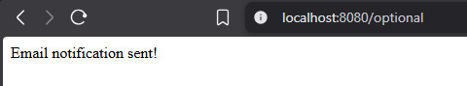

Task 4.6:
Goal: IoC – Inversion of Control.
Basically, instead of programmer manually creating a Dependency to be injected after declaration using the “new” keyword, we let spring handle it as a bean and @Autowired calls that created bean whenever it is required without us explicitly creating an instance of it anywhere.
So basically: You NEVER write new EmployeeService() anywhere, Spring does it for you.
Now, we create:
Employee class:
package com.fsad;

public class Employee {
private int id;
private String name;
public Employee(int id, String name) {
this.id= id;
this.name = name;
}
public int getId() {return id;}
public String getName() {return name;}

}

This will help us create the entry for the database.
EmployeeService class:
package com.fsad;
import org.springframework.stereotype.Component;
@Component
public class EmployeeService {
public Employee getEmployee() {
return new Employee(1,"John Doe");
}
}
Actual data entry happens here.

EmployeeController -> class
package com.fsad;
import org.springframework.beans.factory.annotation.Autowired;
import org.springframework.web.bind.annotation.GetMapping;
import org.springframework.web.bind.annotation.RestController;

@RestController
public class EmployeeController {
@Autowired
EmployeeService employeeService;

@GetMapping("/employee")
public String getEmployee() {
Employee emp = employeeService.getEmployee();
return "ID: "+ emp.getId()+" Name: "+emp.getName();
}

}

When I enter:
http://localhost:8080/employee
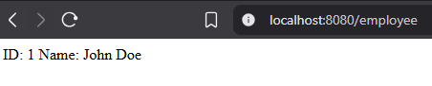

Task 4.7: Spring MVC:
We need a basic Spring MVC controller that accepts and carries out a request.
M- Model (Data – for example, here, it is employee details)
V- View (What the user sees, here it is simple JSON/Text for now)
C – Controller (Handles the request – for instance our @RestController)
NOTE:
Model -> data model to be followed, like we are asking for ID and name right?
Service -> This is basically the logic that we need to perform for the request to be fulfilled
Controller -> It is the extroverted kid who handles communication in a team event

Since the Model and Service already exists, we just need to make the controller:
EmployeeMvcController -> Class:
package com.fsad;
import org.springframework.web.bind.annotation.RestController;
import org.springframework.web.bind.annotation.GetMapping;
import org.springframework.beans.factory.annotation.Autowired;

@RestController
public class EmployeeMvcController {
@Autowired
EmployeeService employeeService;

@GetMapping("/mvc/employee")
public String getEmployeeMvc() {
Employee emp = employeeService.getEmployee();
return "MVC Flow -> ID: "+emp.getId()+" Name: "+emp.getName();
}
}

When I enter:
http://localhost:8080/mvc/employee
